Economics Data-response Question

**Financial Technology Innovations: Cryptocurrency and Virtual Banking**

Personal, Social and Humanities Education Section

Curriculum Development Institute

Education Bureau

2023

(This DRQ is designed by Dr. Lee Shu Kam, Director of Business, Economic and Public Policy Research Centre, Hong Kong Shue Yan University in a project commissioned by the EDB)

**Cryptocurrency and Virtual Banking**

Relevant economic topics: Firms and Production, Market and Price, Competition and Market Structure, National Income Determination and Price Level, Money and Banking

Types of sources: Statistics, news, opinions

**Background: The advancement of technologies in recent years brought about innovations in financial markets such as virtual commodities (e.g. Bitcoin) and virtual banking.**

Source A: An introduction to Bitcoin

.

Bitcoin was the first cryptocurrency introduced in 2009. Bitcoin does not physically exist. It is a digital computer code people store in a virtual wallet in cyberspace and access with a computer or smartphone app. They can be transferred electronically and can be used as a means to “pay” / exchange for goods or services with merchants which accept them. But unlike traditional currencies, Bitcoin is not backed by any bank or government, nor supported by its issuers. In Hong Kong, the creation of Bitcoin is outside the regulatory ambit of the Hong Kong Monetary Authority. Consumers should be cautious when deciding to use, convert, trade, invest or hold it.

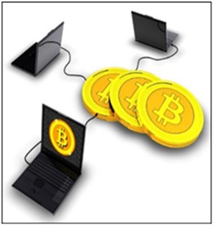

Source: Modified from the Investor and Financial Education Council (IFEC) website ([https://www.ifec.org.hk/web/en/financial-products/fintech/ico-Bitcoin/ico-Bitcoin-cryptocurrencies.page](https://www.ifec.org.hk/web/en/financial-products/fintech/ico-bitcoin/ico-bitcoin-cryptocurrencies.page))

Source B: Bitcoin price (in USD) – from Jan 2015 – Aug 2021

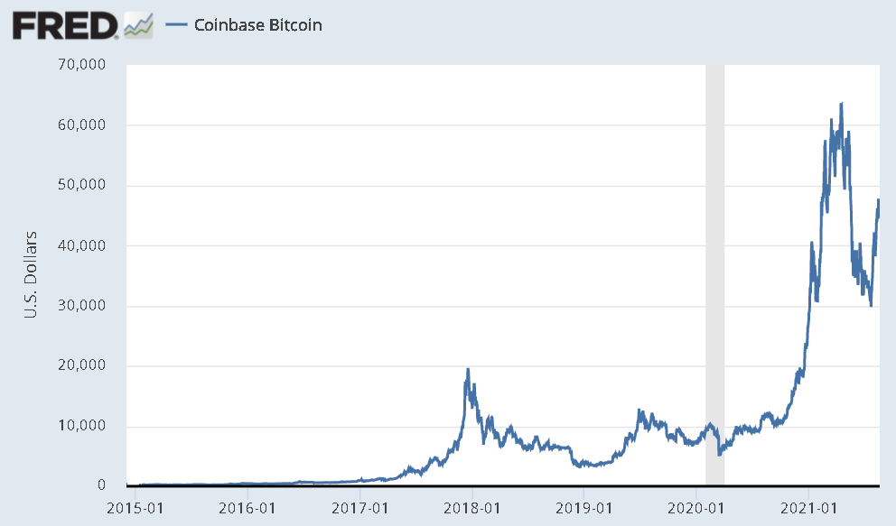

Source: [https://research.stlouisfed.org/publications/page1-econ/2018/03/01/Bitcoin-money-or-financial-investment](https://research.stlouisfed.org/publications/page1-econ/2018/03/01/bitcoin-money-or-financial-investment)

Source C: Number of Bitcoins in circulation from 2015-2020

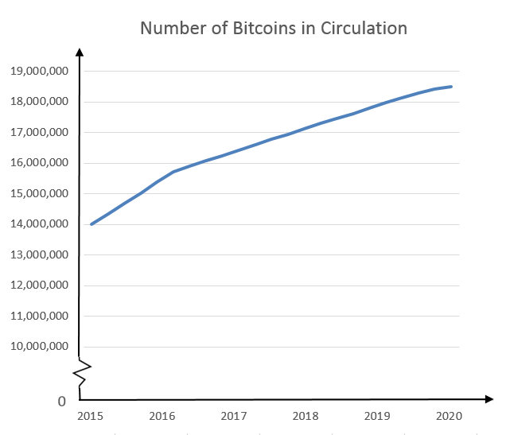

Years

Number of Bitcoins

[Source](https://www.statista.com/statistics/247280/number-of-bitcoins-in-circulation/): https://www.statista.com/statistics/247280/number-of-Bitcoins-in-circulation/

Source D: Introduction to virtual bank

|  |
| --- |
| Virtual bank is defined as a bank which primarily delivers retail banking services through the internet or other forms of electronic channels instead of physical branches. In Hong Kong, virtual banks are subject to the same set of supervisory requirements applicable to conventional banks. As of 3 Janunary 2022, a total of eight virtual banking licences were granted by the Hong Kong Monetary Authority. |

Source: HKMA website (<https://www.hkma.gov.hk/eng/key-functions/banking/banking-regulatory-and-supervisory-regime/virtual-banks/>)

Source E: A dummy advertisement by a virtual bank

**Enjoy high interest rate and innovative Fintech today!!!**

**\*\*The highest interest rate for deposit in Hong Kong**-- 1.3% p.a.**

What’s more? For you, we guarantee



Source: Clipart image captured from the IFEC website <https://www.ifec.org.hk/web/en/financial-products/fintech/virtual-bank/what-is-a-virtual-bank.page>

Source F: Opinions on virtual banks from different stakeholders

|  |  |
| --- | --- |
| A Government Official   | We believe that the development of virtual banks will promote fintech and innovation. Virtual banks can enhance their cost-efficiency by adopting new technologies, such as artificial intelligence (AI) and advanced data analytics. |
| A Human Resource Manager   | Facing the competition from virtual banks, traditional banks are accelerating their adoption of fintech to stay competitive. Banks are now looking for talents that go beyond the traditional set of skills. High-skilled positions in areas such as cybersecurity, data science are now highly paid and demanded. |
|  | Without physical branches, virtual banks would likely adopt different technologies to replace relatively low-skilled labours to lower labour costs. For example, AI-powered chatbots could be used to provide certain customer services non-stop 24 hours a day. |
| Job Seeker A   | Many open positions in virtual banks require some technical skills. These skills could take a few years of education and training to obtain. It’s not easy for me to switch to this industry. |
| Job Seeker B   | As virtual banks primarily deliver services online, I believe it’s more likely for the employees of these companies to work from home, and therefore be less worried about the time and costs of commuting to work! |

Questions:

(a) Refer to Source A. State TWO differences between Bitcoin and Hong Kong dollar. (2 marks)

Ans:

* Bitcoin does not exist physically but Hong Kong dollar exists in the forms of coins and papernotes.
* Bitcoin is not a legal tender but Hong Kong dollar is.
* Bitcoin is not generally accepted in Hong Kong.

(Mark the first 2 points only. Other reasonable answers are also acceptable.)

(b) Refer to Sources A and B. Explain in terms of the functions of money why it may not be attractive for people to use Bitcoin as money in Hong Kong. (4 marks)

Ans: With respect to the function of store of value, the price of Bitcoin fluctuates while that of Hong Kong dollar tends to be more stable, hence, Bitcoin is not a good form of money. In addition, in terms of general acceptability, not all merchants in Hong Kong accept Bitcoin for settling payments. Therefore, it is not attractive for people to use Bitcoin as money in Hong Kong.

(c) Refer to Sources B and C. With the aid of TWO separate demand and supply diagrams, illustrate the price changes of Bitcoin in the following periods:

1. 2017-2018, when Bitcoin was rapidly gaining popularity (5 marks)
2. 2018-2019, when some people feared about regulations about Bitcoin trading (4 marks)

Ans: (i)

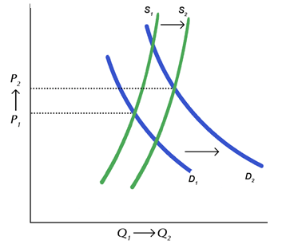

Price

Quantity

0

* The rise of Bitcoin price in 2017-2018 may be caused by the magnitude of increase in demand, due to the rapid growth in popularity,is greater than the magnitude of increase in supply. The rightward shift of the demand curve has outweighed the rightward shift of the supply curve, resulting in a higher equilibrium price.

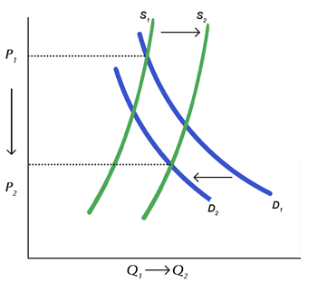(ii)

0

Price

Quantity

* The drop in Bitcoin price in 2018-2019 maybe casued by a decrease in demand, due to the fears about regulations of Bitcoin trading, and an increase in supply. The demand curve shifts to the left and the supply curve shifts to the right, resulting in a drop in the equilibrium price.

(d) Refer to Sources A, D & E.

(i) Describe the role of the Hong Kong Monetary Authority in the creation of Bitcoin and the entrance of a virtual bank. (2 marks)

Ans: The Hong Kong Monetary Authority plays a supervising role in the entrance of virtual banks. Bitcoin is not considered as legal tender but a virtual commodity, which is not backed by any physical items, issuers, or the government. The creation of Bitcoin is outside the regulatory ambit of the Hong Kong Monetary Authority.

(ii) Is the deposit market in the banking system perfectly competitive? Explain your answers. (2 marks)

Ans: It is not a perfectly competitive market since different banks offer different interest rates and banks need to advertise their deposit services.

(iii) Suppose more people are transferring cash in hand to deposit accounts in virtual banks due to the more attractive saving interest rates and the more inclusive banking services. How would this affect the credit creation power of the banking system? (2 marks)

Ans: When more people turn their cash to deposit (i.e. a reduction in cash leakage), the banking system will have a larger amount of reserves for loans and hence its credit creation power would increase.

(e) Refer to Source E.

(i) In terms of labour mobility, what are the respective conern of job seekers A and B? (2 marks)

Ans: Job Seeker A concerns about occupational mobility and Job Seeker B concerns about geographical mobility

(ii) Give a suggestion to address Job Seeker A’s concern. (2 marks)

Ans: The government could subsidize the less skilled labours to acquire needed technical skills.

(Other reasonable answers are also accepted.)

For part (f), candidates are required to present their answers in essay form. Criteria for marking will include the use of sources and economic theories, relevant content, logical presentation and clarity of expression.

(f) With reference to the sources above and your knowledge in economics, discuss the possible impacts of the development of the virtual banks on the economy, including:

* Aggregate output
* Income inequality
* Other economic variable(s) (10 marks)

Ans: After the introduction of virtual banks, a more competitive banking industry could spur innovation and speed up technological advances. The increased adoption of artificial intelligence and automation in the industry can increase productivity and therefore aggregate supply. The increase in aggregate supply is represented by a rightward shift of the short run and long run aggregate supply curves in the AS-AD model. As a result, the aggregate output increases.

[Remarks: It is accepted when students follow the reasoning in d(iii) and argue that the money supply would increase and that will lead to an increase in AD]

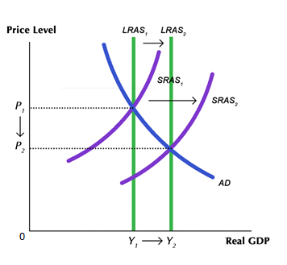

Aggregate output

Income inequality may be worsened. According to the sources, the new business model of virtual banks and its technology adoption creates more demand for high-skilled labour and therefore push up the salary level of these high-skilled labours. Facing the competition from virtual banks, traditional banks would also accelerate fintech adoption to stay competitive in the industry. On the other hand, the demand for low-skilled labour may decrease, as some relatively low-skill labour could be replaced by some technologies, such as AI-powered chatbots. Their income may hence decrease.

Other economic variable(s):

* Unemployment

The impact on unemployment is uncertain. While the demand for some jobs which are easily replaced by automation such as tellers or security guards, would decrease; the demand for other IT related jobs would increase (for example, cybersecurity professionals, application developers or data scientists).

* Average labour productivity

With the introduction of virtual banks, the keener competition in the banking industry will drive the industry to utilise more high-technology and hire more high-skilled workers. With better equipment the average labour productivity would be raised.

(Students may apply their knowledge in economics to make reasonable explanation to support their views)